class parent
{ final void display()
{
System.out.println("final method in parent class");
}
}
class child extends parent
Name of Student: Husam Ali Abdalla Nour | PRN:2507012209086
Semester: III | Year : AY 2026-27
Subject: Programming with Java
ASSIGNMENT No : 9
TITLE : Final Keyword in Java
Problem Statement
Write a Java program to demonstrate the use of the final keyword with variables, methods, and classes.
Learning Objectives
To implement the final keyword with variables, methods, and classes.

Programme

final class FinalClass
{ void display()
{
System.out.println("this is a final class"); }
}
public class FinalClas
{ public static void main(String[] args) {
FinalClass obj = new FinalClass();
obj.display();
}
}
Finalmethod

Output Final class
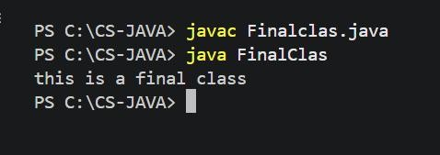
{
// void display() {} compilation error if attempted
}
public class FinalMethodExample
{ public static void main(String[] args)
{ child c= new child(); c.display();
}
}

Final method
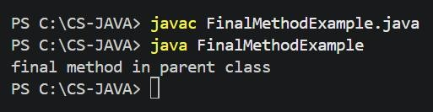

Conclusion
In conclusion, this assignment demonstrated the use of the final keyword in Java with variables, methods, and classes. We learned that a final variable cannot be changed once assigned, a final method cannot be overridden, and a final class cannot be inherited.

